Task 1

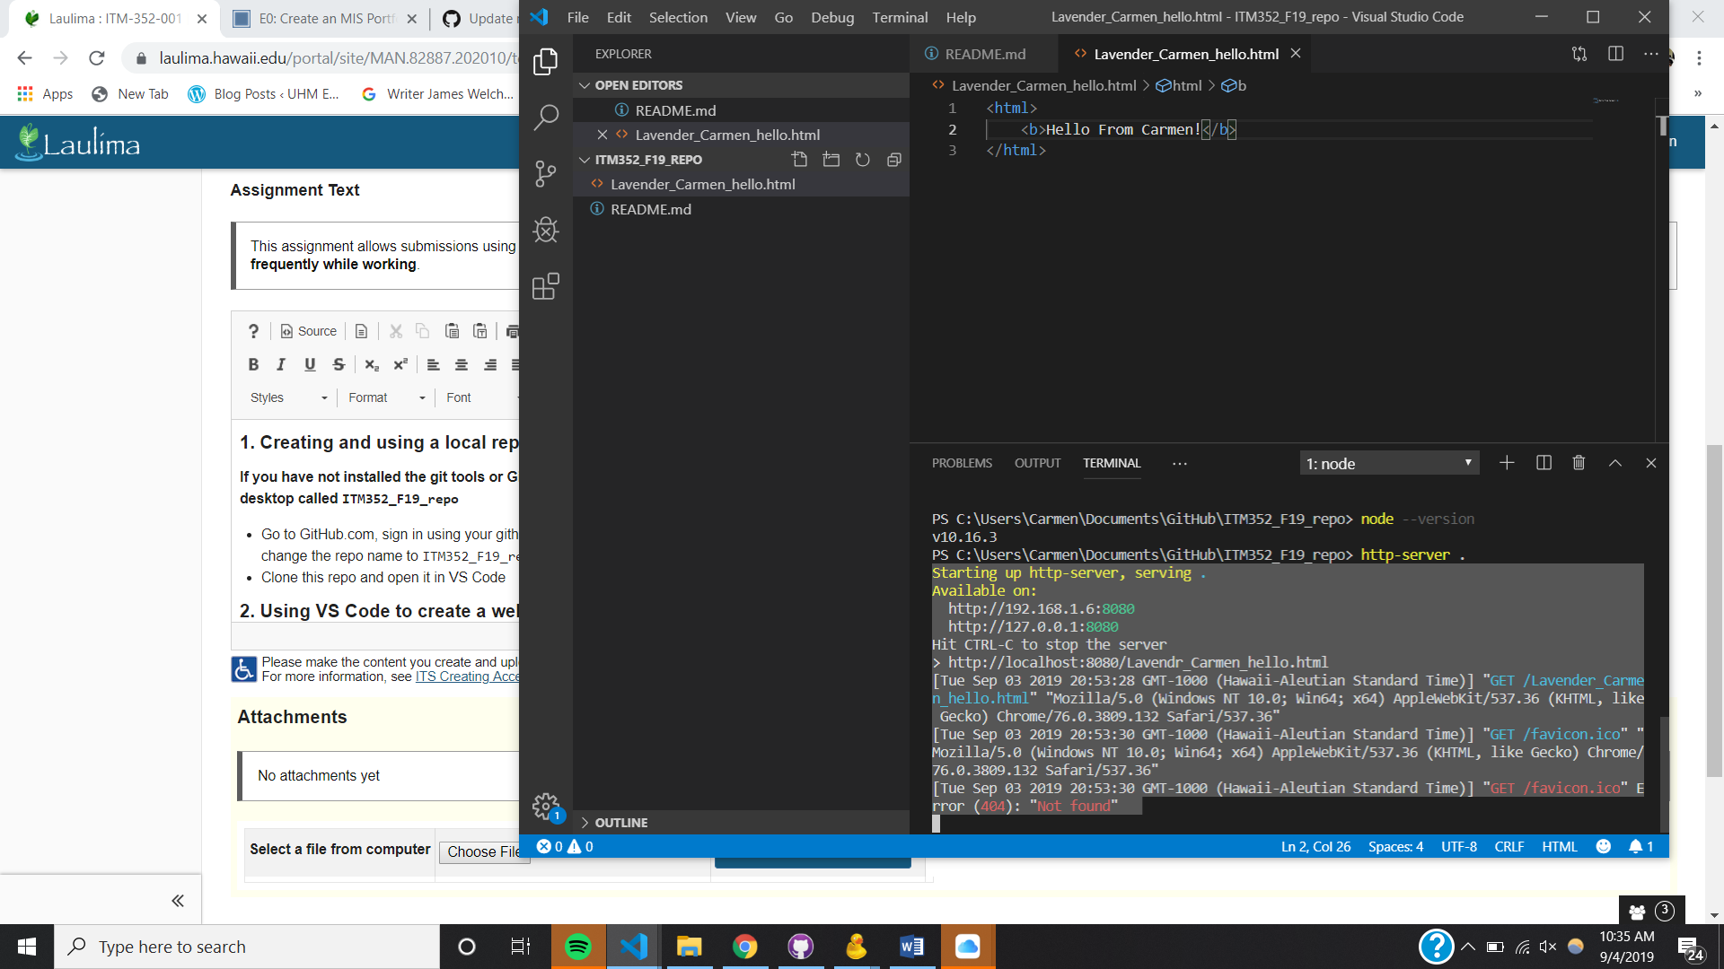

Task 4

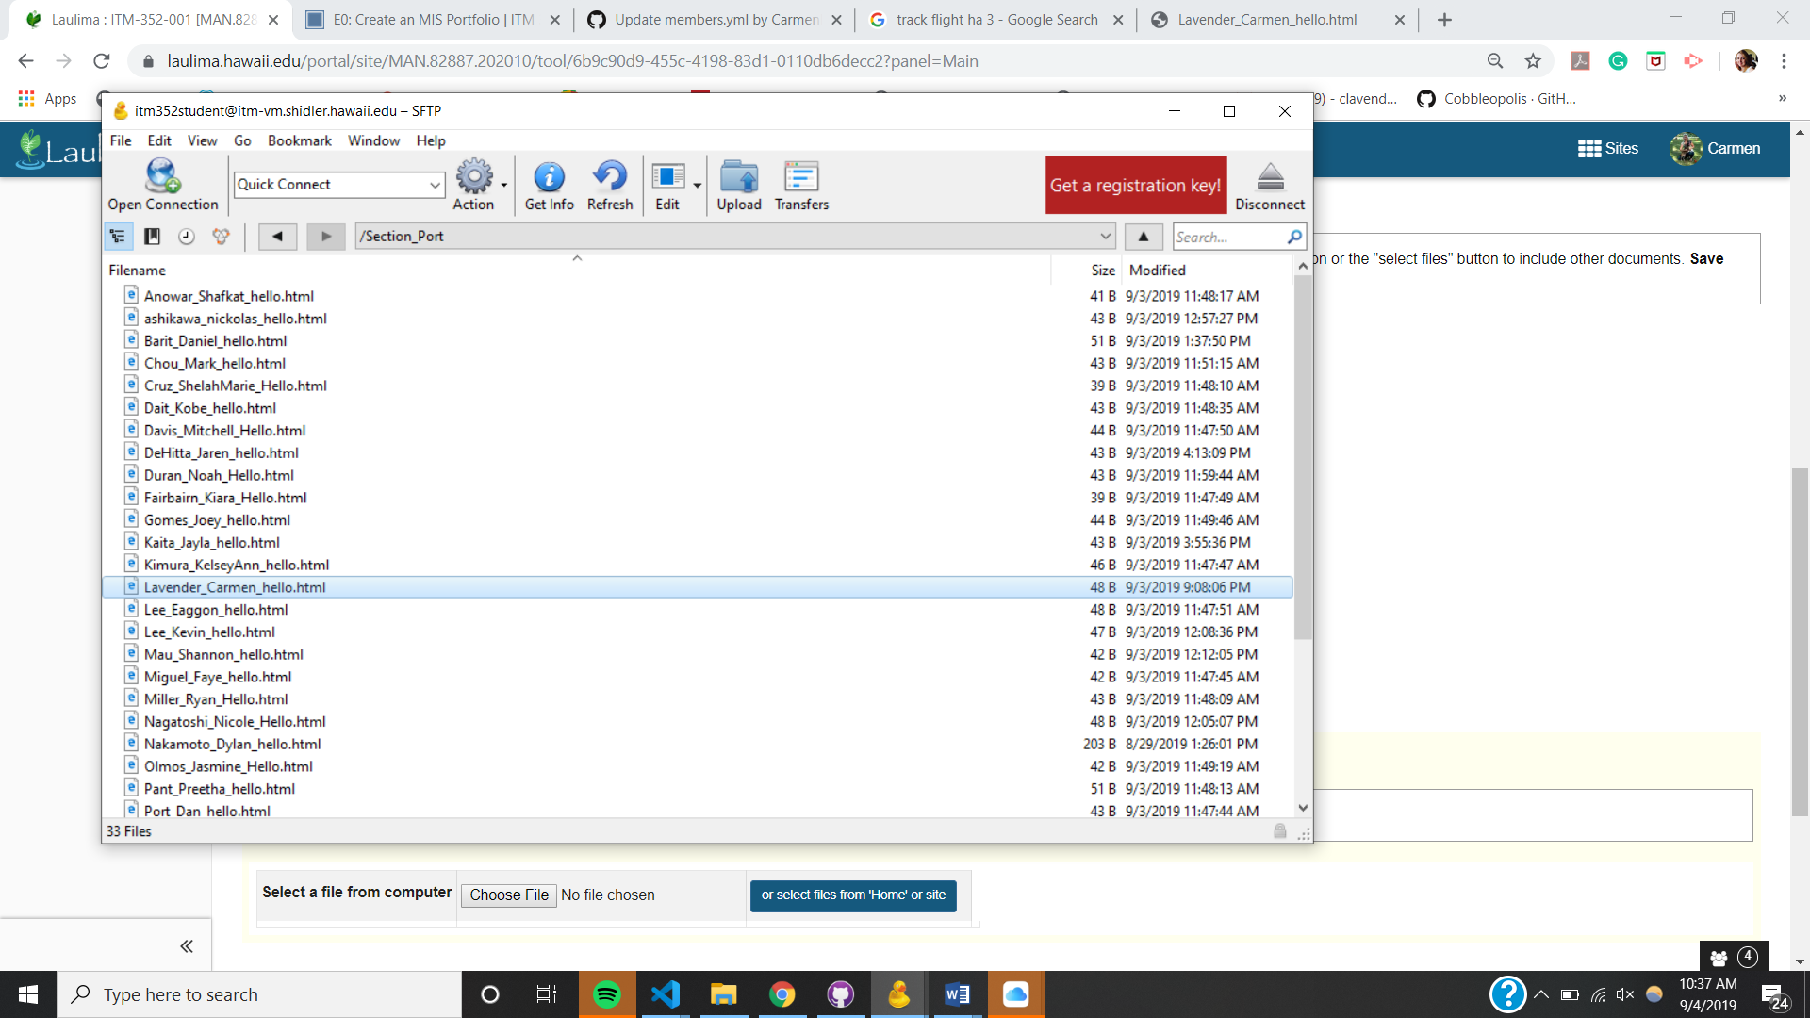

Windows PowerShell

Copyright (C) Microsoft Corporation. All rights reserved.

Try the new cross-platform PowerShell https://aka.ms/pscore6

PS C:\Users\Carmen\Documents\GitHub\ITM352_F19_repo> npm install live-server -g

npm WARN deprecated opn@6.0.0: The package has been renamed to `open`

C:\Users\Carmen\AppData\Roaming\npm\live-server -> C:\Users\Carmen\AppData\Roaming\npm\node_modules\live-server\live-server.js

npm WARN optional SKIPPING OPTIONAL DEPENDENCY: fsevents@1.2.9 (node_modules\live-server\node_modules\fsevents):

npm WARN notsup SKIPPING OPTIONAL DEPENDENCY: Unsupported platform for fsevents@1.2.9: wanted {"os":"darwin","arch":"any"} (current: {"os":"win32","arch":"x64"})

+ live-server@1.2.1

added 191 packages from 149 contributors in 35.453s

PS C:\Users\Carmen\Documents\GitHub\ITM352_F19_repo>

Windows PowerShell

Copyright (C) Microsoft Corporation. All rights reserved.

Try the new cross-platform PowerShell https://aka.ms/pscore6

PS C:\Users\Carmen\Documents\GitHub\ITM352_F19_repo> npm install live-server -g

npm WARN deprecated opn@6.0.0: The package has been renamed to `open`

C:\Users\Carmen\AppData\Roaming\npm\live-server -> C:\Users\Carmen\AppData\Roaming\npm\node_modules\live-server\live-server.js

npm WARN optional SKIPPING OPTIONAL DEPENDENCY: fsevents@1.2.9 (node_modules\live-server\node_modules\fsevents):

npm WARN notsup SKIPPING OPTIONAL DEPENDENCY: Unsupported platform for fsevents@1.2.9: wanted {"os":"darwin","arch":"any"} (current: {"os":"win32","arch":"x64"})

+ live-server@1.2.1

added 191 packages from 149 contributors in 35.453s

PS C:\Users\Carmen\Documents\GitHub\ITM352_F19_repo> http-server

Starting up http-server, serving ./

Available on:

http://168.105.2.196:8082

http://127.0.0.1:8082

Hit CTRL-C to stop the server

> npm install live-server -g

Windows PowerShell

Copyright (C) Microsoft Corporation. All rights reserved.

Try the new cross-platform PowerShell https://aka.ms/pscore6

PS C:\Users\Carmen\Documents\GitHub\ITM352_F19_repo> npm install live-server -g

npm WARN deprecated opn@6.0.0: The package has been renamed to `open`

> C:\Users\Carmen\AppData\Roaming\npm\live-server -> C:\Users\Carmen\AppData\Roaming\npm\node_modules\live-server\live-server.js

> npm WARN optional SKIPPING OPTIONAL DEPENDENCY: fsevents@1.2.9 (node_modules\live-server\node_modules\fsevents):

> npm WARN notsup SKIPPING OPTIONAL DEPENDENCY: Unsupported platform for fsevents@1.2.9: wanted {"os":"darwin","arch":"any"} (current: {"os":"win32","arch":"x64"})

+ live-server@1.2.1

added 191 packages from 149 contributors in 35.453s

PS C:\Users\Carmen\Documents\GitHub\ITM352_F19_repo> Windows PowerShell

Copyright (C) Microsoft Corporation. All rights reserved.

Try the new cross-platform PowerShell https://aka.ms/pscore6

PS C:\Users\Carmen\Documents\GitHub\ITM352_F19_repo> npm install live-server -g

npm WARN deprecated opn@6.0.0: The package has been renamed to `open`

> C:\Users\Carmen\AppData\Roaming\npm\live-server -> C:\Users\Carmen\AppData\Roaming\npm\node_modules\live-server\live-server.js

> npm WARN optional SKIPPING OPTIONAL DEPENDENCY: fsevents@1.2.9 (node_modules\live-server\node_modules\fsevents):

> npm WARN notsup SKIPPING OPTIONAL DEPENDENCY: Unsupported platform for fsevents@1.2.9: wanted {"os":"darwin","arch":"any"} (current: {"os":"win32","arch":"x64"})

+ live-server@1.2.1

added 191 packages from 149 contributors in 35.453s

PS C:\Users\Carmen\Documents\GitHub\ITM352_F19_repo> Windows PowerShell

Copyright (C) Microsoft Corporation. All rights reserved.

Try the new cross-platform PowerShell https://aka.ms/pscore6

PS C:\Users\Carmen\Documents\GitHub\ITM352_F19_repo> npm install live-server -g

npm WARN deprecated opn@6.0.0: The package has been renamed to `open`

> C:\Users\Carmen\AppData\Roaming\npm\live-server -> C:\Users\Carmen\AppData\Roaming\npm\node_modules\live-server\live-server.js

> npm WARN optional SKIPPING OPTIONAL DEPENDENCY: fsevents@1.2.9 (node_modules\live-server\node_modules\fsevents):

> npm WARN notsup SKIPPING OPTIONAL DEPENDENCY: Unsupported platform for fsevents@1.2.9: wanted {"os":"darwin","arch":"any"} (current: {"os":"win32","arch":"x64"})

+ live-server@1.2.1

added 191 packages from 149 contributors in 35.453s

PS

http-server stopped.

PS C:\Users\Carmen\Documents\GitHub\ITM352_F19_repo> live-server

http://0.0.0.0:8080 is already in use. Trying another port.

Ready for changes

Serving "C:\Users\Carmen\Documents\GitHub\ITM352_F19_repo" at http://127.0.0.1:54823

Change detected C:\Users\Carmen\Documents\GitHub\ITM352_F19_repo\SmartPhoneProducts1\Store.html

Change detected C:\Users\Carmen\Documents\GitHub\ITM352_F19_repo\SmartPhoneProducts1\Store.html

Change detected C:\Users\Carmen\Documents\GitHub\ITM352_F19_repo\SmartPhoneProducts1\index.html

Change detected C:\Users\Carmen\Documents\GitHub\ITM352_F19_repo\SmartPhoneProducts1\Store.html

GET /SmartPhoneProducts1/Store.html 404 11.087 ms - 169

GET /SmartPhoneProducts1/Store.html 404 32.085 ms – 169

GET /SmartPhoneProducts1/Store.html 404 11.087 ms - 169

GET /SmartPhoneProducts1/Store.html 404 32.085 ms - 169

Change detected C:\Users\Carmen\Documents\GitHub\ITM352_F19_repo\SmartPhoneProducts1\images

Change detected C:\Users\Carmen\Documents\GitHub\ITM352_F19_repo\SmartPhoneProducts1\images

Change detected C:\Users\Carmen\Documents\GitHub\ITM352_F19_repo\SmartPhoneProducts1\images

Change detected C:\Users\Carmen\Documents\GitHub\ITM352_F19_repo\SmartPhoneProducts1\images\phone_globe.jpg

Change detected C:\Users\Carmen\Documents\GitHub\ITM352_F19_repo\SmartPhoneProducts1\index.html

http-server stopped.

PS C:\Users\Carmen\Documents\GitHub\ITM352_F19_repo> live-server

http://0.0.0.0:8080 is already in use. Trying another port.

Ready for changes

Serving "C:\Users\Carmen\Documents\GitHub\ITM352_F19_repo" at http://127.0.0.1:54823

Change detected C:\Users\Carmen\Documents\GitHub\ITM352_F19_repo\SmartPhoneProducts1\Store.html

Change detected C:\Users\Carmen\Documents\GitHub\ITM352_F19_repo\SmartPhoneProducts1\Store.html

Change detected C:\Users\Carmen\Documents\GitHub\ITM352_F19_repo\SmartPhoneProducts1\index.html

Change detected C:\Users\Carmen\Documents\GitHub\ITM352_F19_repo\SmartPhoneProducts1\Store.html

GET /SmartPhoneProducts1/Store.html 404 11.087 ms - 169

GET /SmartPhoneProducts1/Store.html 404 32.085 ms - 169

Change detected C:\Users\Carmen\Documents\GitHub\ITM352_F19_repo\SmartPhoneProducts1\images

Change detected C:\Users\Carmen\Documents\GitHub\ITM352_F19_repo\SmartPhoneProducts1\images

Change detected C:\Users\Carmen\Documents\GitHub\ITM352_F19_repo\SmartPhoneProducts1\images

Change detected C:\Users\Carmen\Documents\GitHub\ITM352_F19_repo\SmartPhoneProducts1\images\phone_globe.jpg

Change detected C:\Users\Carmen\Documents\GitHub\ITM352_F19_repo\SmartPhoneProducts1\index.html

Change detected C:\Users\Carmen\Documents\GitHub\ITM352_F19_repo\SmartPhoneProducts1\index.html

Change detected C:\Users\Carmen\Documents\GitHub\ITM352_F19_repo\SmartPhoneProducts1\index.html

Change detected C:\Users\Carmen\Documents\GitHub\ITM352_F19_repo\SmartPhoneProducts1\products_page.html

Change detected C:\Users\Carmen\Documents\GitHub\ITM352_F19_repo\SmartPhoneProducts1\products_page.html

Change detected C:\Users\Carmen\Documents\GitHub\ITM352_F19_repo\SmartPhoneProducts1\products_page.html

Change detected C:\Users\Carmen\Documents\GitHub\ITM352_F19_repo\SmartPhoneProducts1\products_page.html

Change detected C:\Users\Carmen\Documents\GitHub\ITM352_F19_repo\SmartPhoneProducts1\products_page.html

Change detected C:\Users\Carmen\Documents\GitHub\ITM352_F19_repo\SmartPhoneProducts1\index.html

Change detected C:\Users\Carmen\Documents\GitHub\ITM352_F19_repo\SmartPhoneProducts1\index.html

Change detected C:\Users\Carmen\Documents\GitHub\ITM352_F19_repo\SmartPhoneProducts1\index.html

Change detected C:\Users\Carmen\Documents\GitHub\ITM352_F19_repo\SmartPhoneProducts1\index.html

Change detected C:\Users\Carmen\Documents\GitHub\ITM352_F19_repo\SmartPhoneProducts1\index.html

<html lang="en">

<head>

    <meta charset="UTF-8">

    <meta name="viewport" content="width=device-width, initial-scale=1.0">

    <meta http-equiv="X-UA-Compatible" content="ie=edge">

    <title>Document</title>

    <stlye>

        body (

            text-align: center;

            background: red;

        )

    </stlye>

</head>

<body>

    <h1>Smartphone Store Home</h1>

    <a href="./products_page.html">

    <img src="./images/phone_globe.jpg" height="200px" width="200px"></a>

    <h1>Click the image to enter store</h1>

</body>

</html>